C0453 Web Applications

App 01 Miles to Feet Converter

Student Name: Marius Boncica

# Stage 1

## Activity Diagram

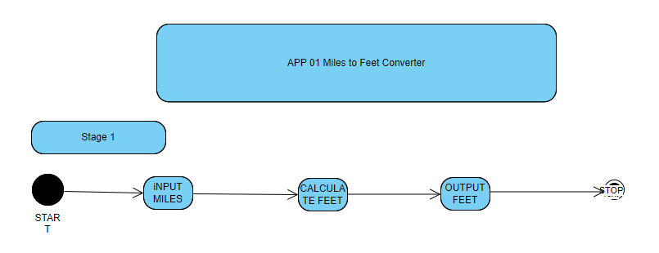

## UML DIAGRAM

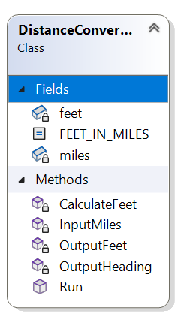

## TEST STAGE 1

